Photo Compilation for engAGED Community Awareness Toolkit

engAGED compiled free photos for organizations to use on social media and in newsletters to depict social engagement.

Image | Link to Download | Alt Text | Additional Information
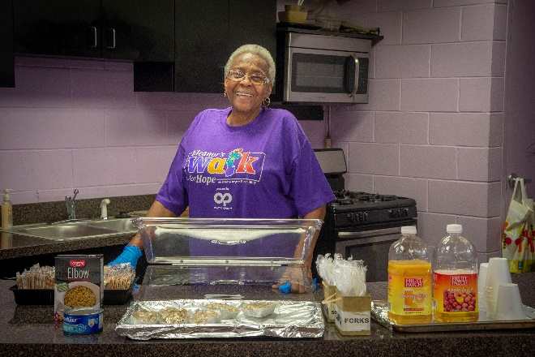 | Download the image | Older woman smiling and distributing meal samples to participants at a local agency. | U.S. Department of Agriculture Photo by Preston Keres
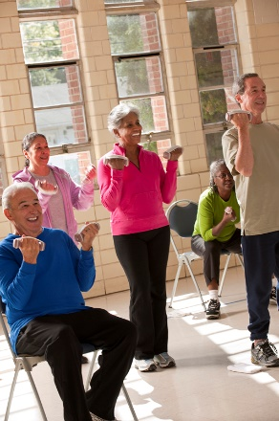 | Download the image | A group of older adults lifting hand weights in an exercise class. | Digital images are free for non-commercial, non-profit use. They are provided by the USDA's Food and Nutrition Service (FNS), Supplemental Nutrition Assistance Program.
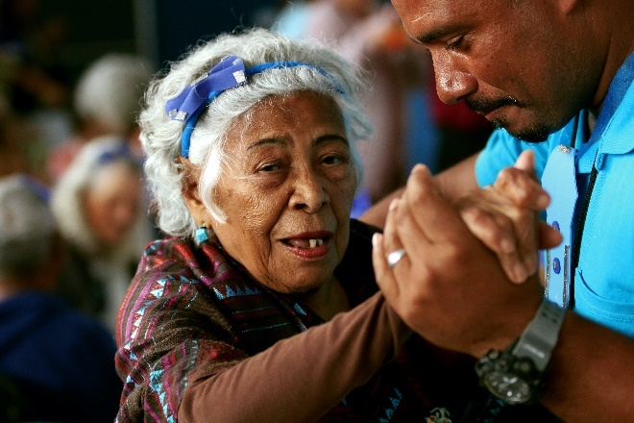 | Download the image | Older woman dancing with a man. | Photo by Vladimir Soares on Unsplash
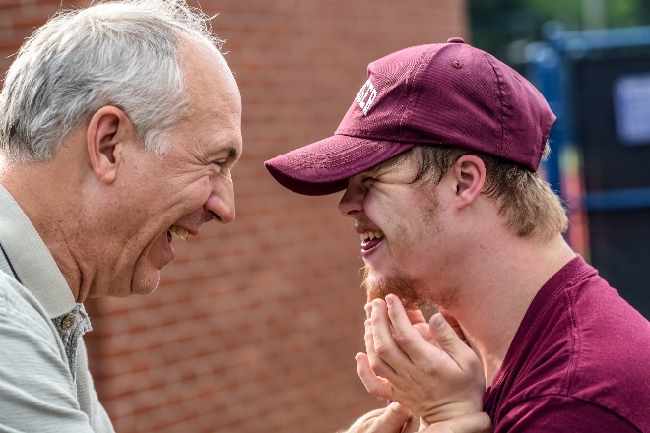 | Download the image | Older man and younger man laughing together. | Photo by Nathan Anderson on Unsplash
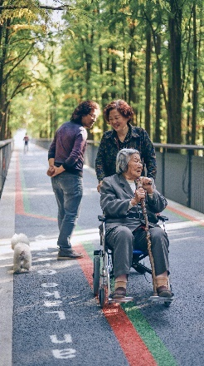 | Download the image | Older woman in a wheelchair with two other people and a dog on an outdoor walking path. | Photo by Raychan on Unsplash
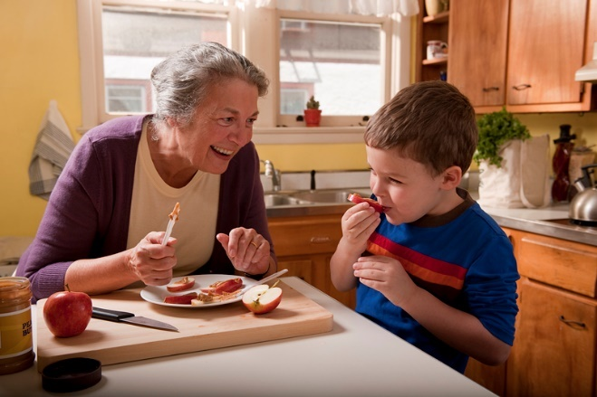 | Download the image | An older woman and a young boy prepare a healthy snack. | Digital images are free for non-commercial, non-profit use. They are provided by the USDA's Food and Nutrition Service (FNS), Supplemental Nutrition Assistance Program.
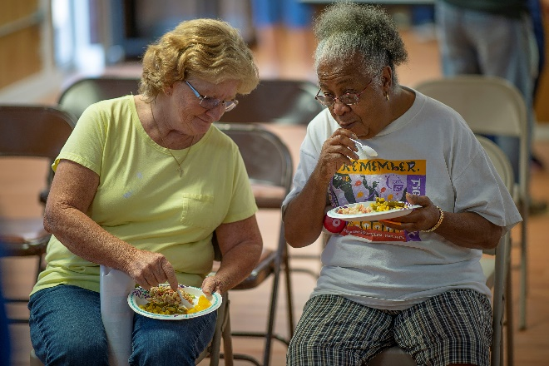 | Download the image | Two older women eating a meal together. | U.S. Department of Agriculture Photo by Preston Keres
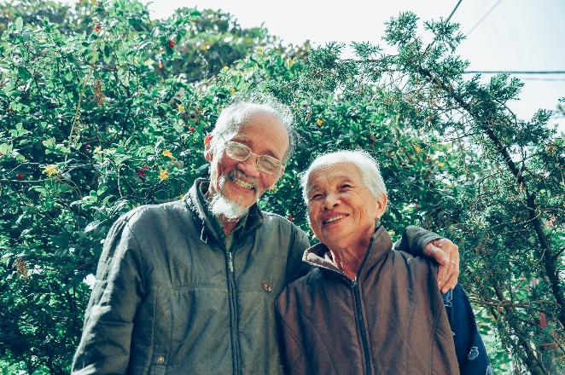 | Download the image | An older man and woman smiling in nature. | Photo by Tristan Le
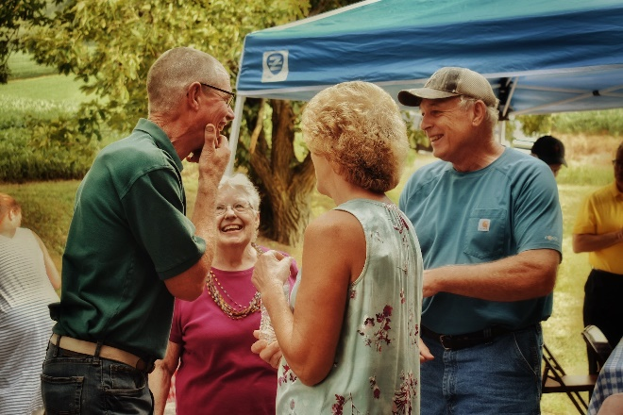 | Download the image | A group of older adults at an outdoor gathering. | Photo by Leah Hetteberg on Unsplash
 | Download the image | An older couple smiling while looking at each other and drinking coffee/tea in front of a laptop. | Photo by Marcus Aurelius
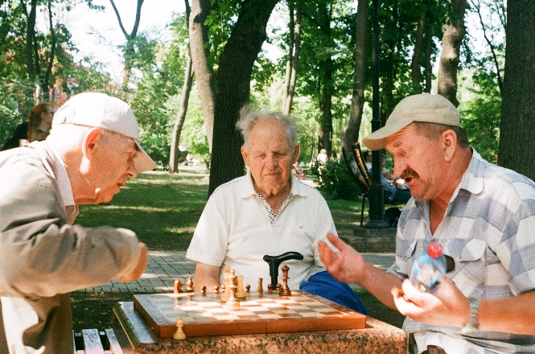 | Download the image | Three older men playing chess outdoors. | Photo by Юлія Вівчарик on Unsplash
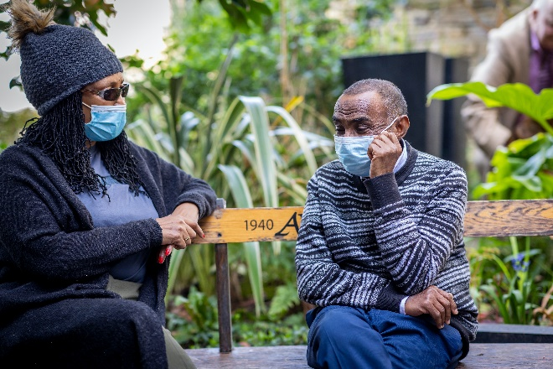 | Download the image | A man and woman talking on a bench with masks on. | Photo by Centre for Ageing Better on Unsplash
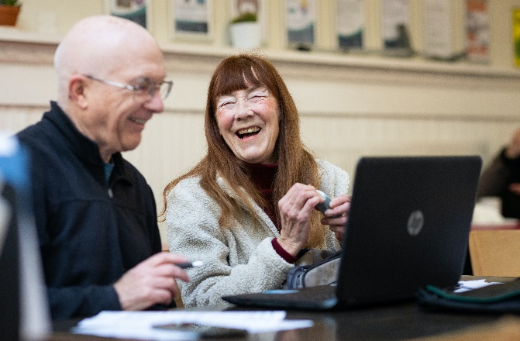 | Download the image | A man and woman sitting at a table with a laptop. | Photo by Centre for Ageing Better on Unsplash
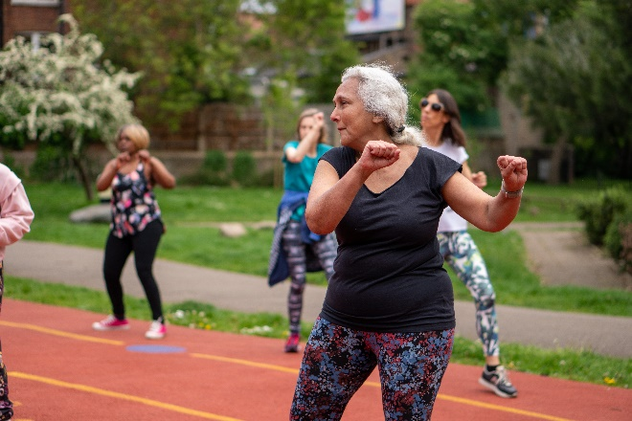 | Download the image | A group of women exercising outdoors on a track. | Photo by Centre for Ageing Better on Unsplash
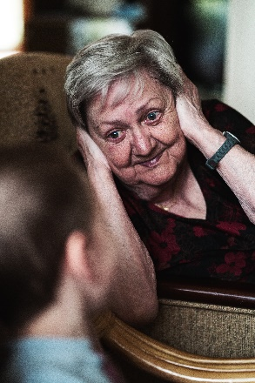 | Download the image | An older woman covering her ears with a young child. | Photo by William Krause on Unsplash
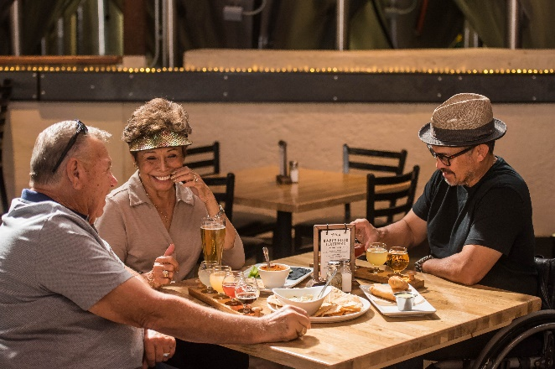 | Download the image | Three adults having a meal at a restaurant. | Photo by ELEVATE
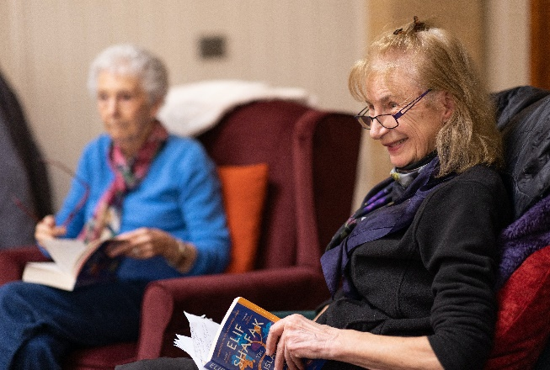 | Download the image | Two older women sitting in chairs reading books. | Photo by Centre for Ageing Better on Unsplash
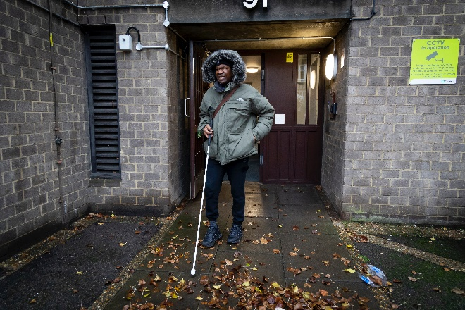 | Download the image | Blind man with cane walking outside. | Photo by Centre for Ageing Better on Unsplash
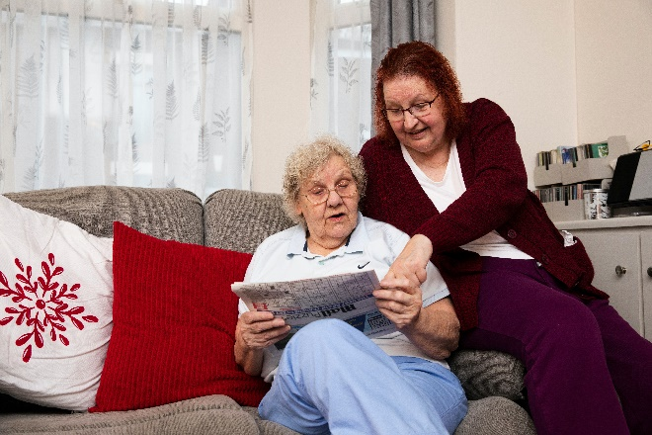 | Download the image | Two women on a couch reading a newspaper. | Photo by Centre for Ageing Better on Unsplash
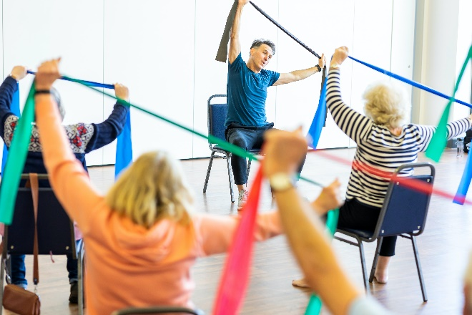 | Download the image | A group of older adults exercising in chairs using resistance bands. | Photo by Centre for Ageing Better on Unsplash
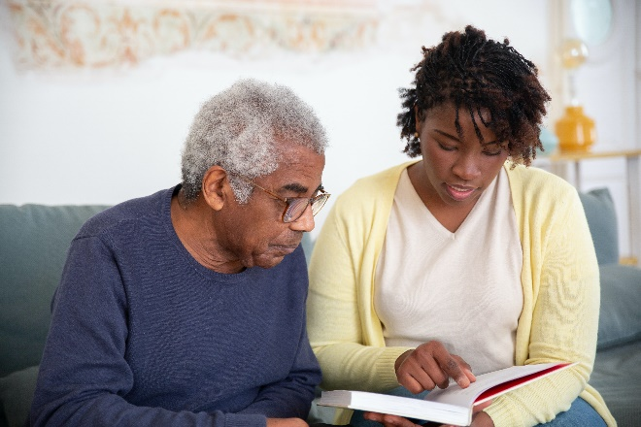 | Download the image | Young woman reading a book with an older man. | Photo by Kampus Production
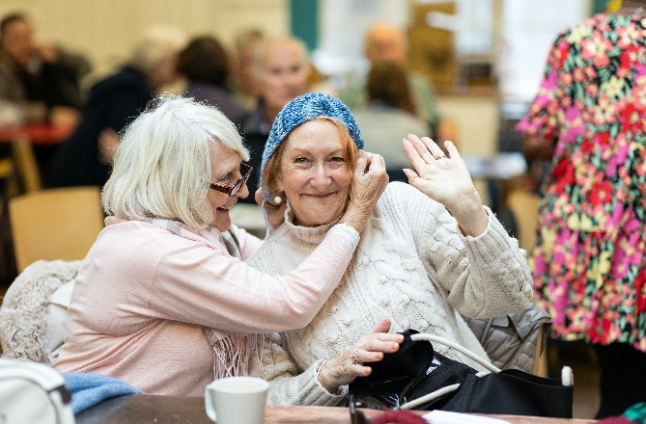 | Download the image | Two older women sitting at a table together. | Photo by Centre for Ageing Better on Unsplash
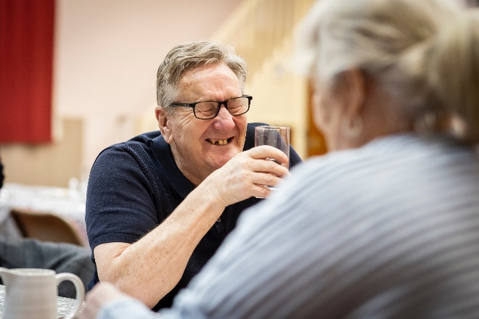 | Download the image | Older man laughing. | Photo by Centre for Ageing Better on Unsplash
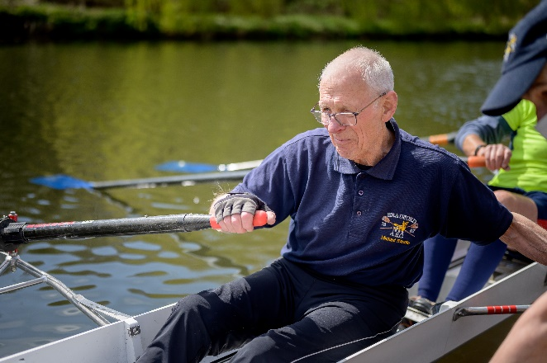 | Download the image | Older man in a canoe. | Photo by Centre for Ageing Better on Unsplash
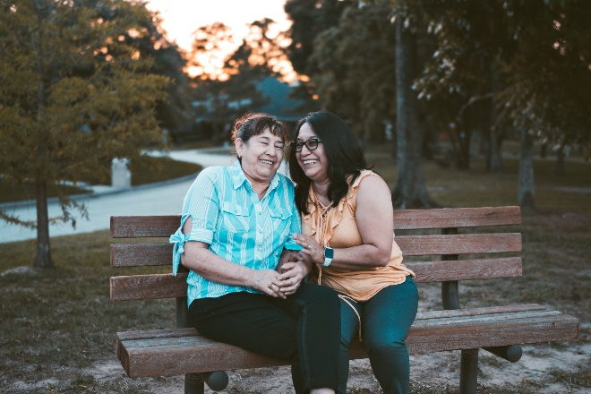 | Download the image | Two women laughing together on a bench. | Photo by Dario Valenzuela on Unsplash
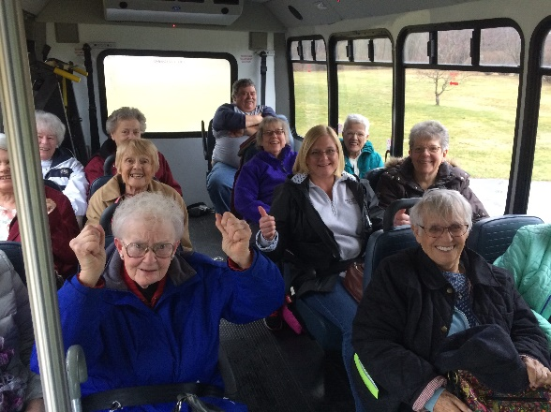 | To download the image, visit the NADTC Photo Gallery and create a free account. This photo is located under “Older Adults.” | Smiling older adults on a bus. | NADTC Photo Gallery  Credit: Town of Suffield - Senior Center & Mini Bus Transportation Suffield, CT
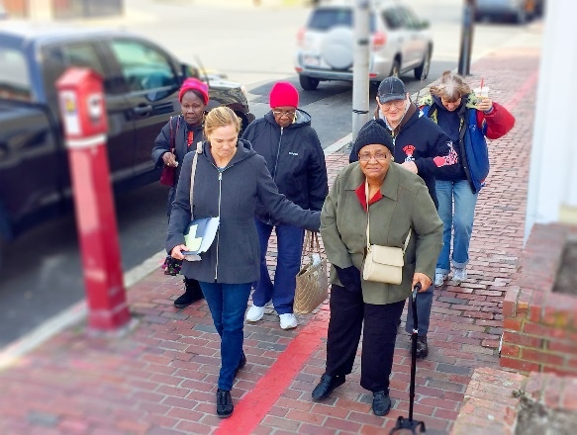 | To download the image, visit the NADTC Photo Gallery and create a free account. This photo is located under “Older Adults.” | Travel trainer providing group training to older adults. | NADTC Photo Gallery  Credit: Greater Lynn Senior Services Lynn, MA
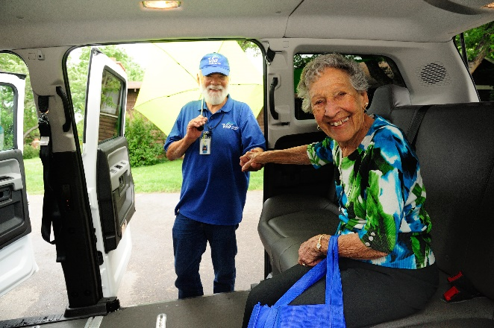 | To download the image, visit the NADTC Photo Gallery and create a free account. This photo is located under “Volunteer Transportation / Shared Rides.” | Volunteer driver assisting woman out of vehicle. | NADTC Photo Gallery  Credit: Via Mobility Services, Boulder, CO
 | To download the image, visit the NADTC Photo Gallery and create a free account. This photo is located under “Volunteer Transportation / Shared Rides.” | Man assisting woman with cane exiting vehicle. | NADTC Photo Gallery  Credit: Metrolina Association for the Blind, Charlotte, NC
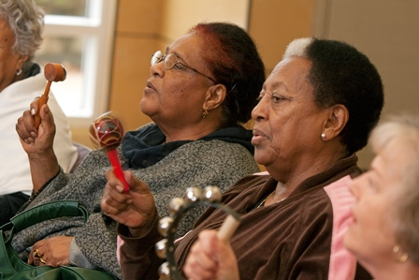 | Link to download | Older women in a music class. | Photo by Eldercare Locator
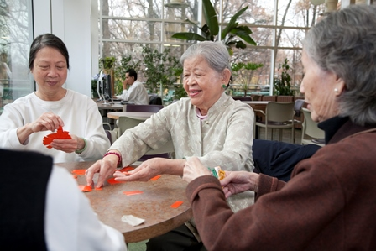 | Link to download | Older women playing a card game. | Photo by Eldercare Locator
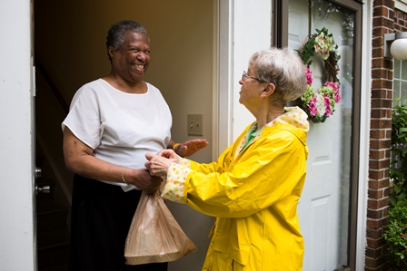 | Link to download | Older adult volunteer delivering a meal. | Photo by Eldercare Locator
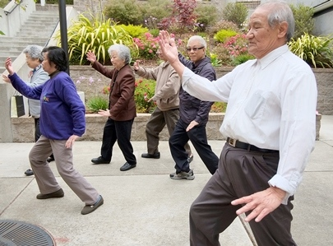 | Link to download | Older adults participating in a Tai Chi class outdoors. | Photo by Eldercare Locator
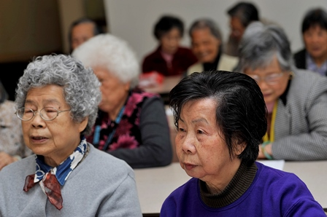 | Link to download | Older adults in a group education class. | Photo by Eldercare Locator
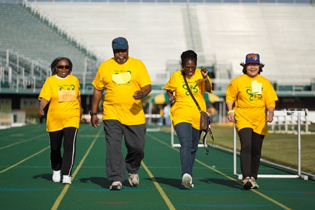 | Link to download | Older adults walking on an outdoor track | Photo by Eldercare Locator

